|  |
| --- |
|  |
| The Documentation |
| [Type the document subtitle] |
|  |
| **[Your Name]** |
| **[Pick the date]** |

[Type the abstract of the document here. The abstract is typically a short summary of the contents of the document. Type the abstract of the document here. The abstract is typically a short summary of the contents of the document.]

Table of Contents

[To update the table of contents, right click the message below and select Update Field (F9 on PC, ⌥⌘U on Mac).]

**No table of contents entries found.**

1. Pages
   1. Page Tree

Landing page  
 Form  
 Faq's  
 Noticias relacionadas  
Login  
 Admin  
 Graficas Admin  
 Admin Page  
 Gestion campos  
 Parcelas Admin  
 User  
 Tiempo User  
 Graficas User  
 Parcelas User  
 Recuperar Password

* 1. Landing page
     1. User Interface

iPhone 8



iPad 4

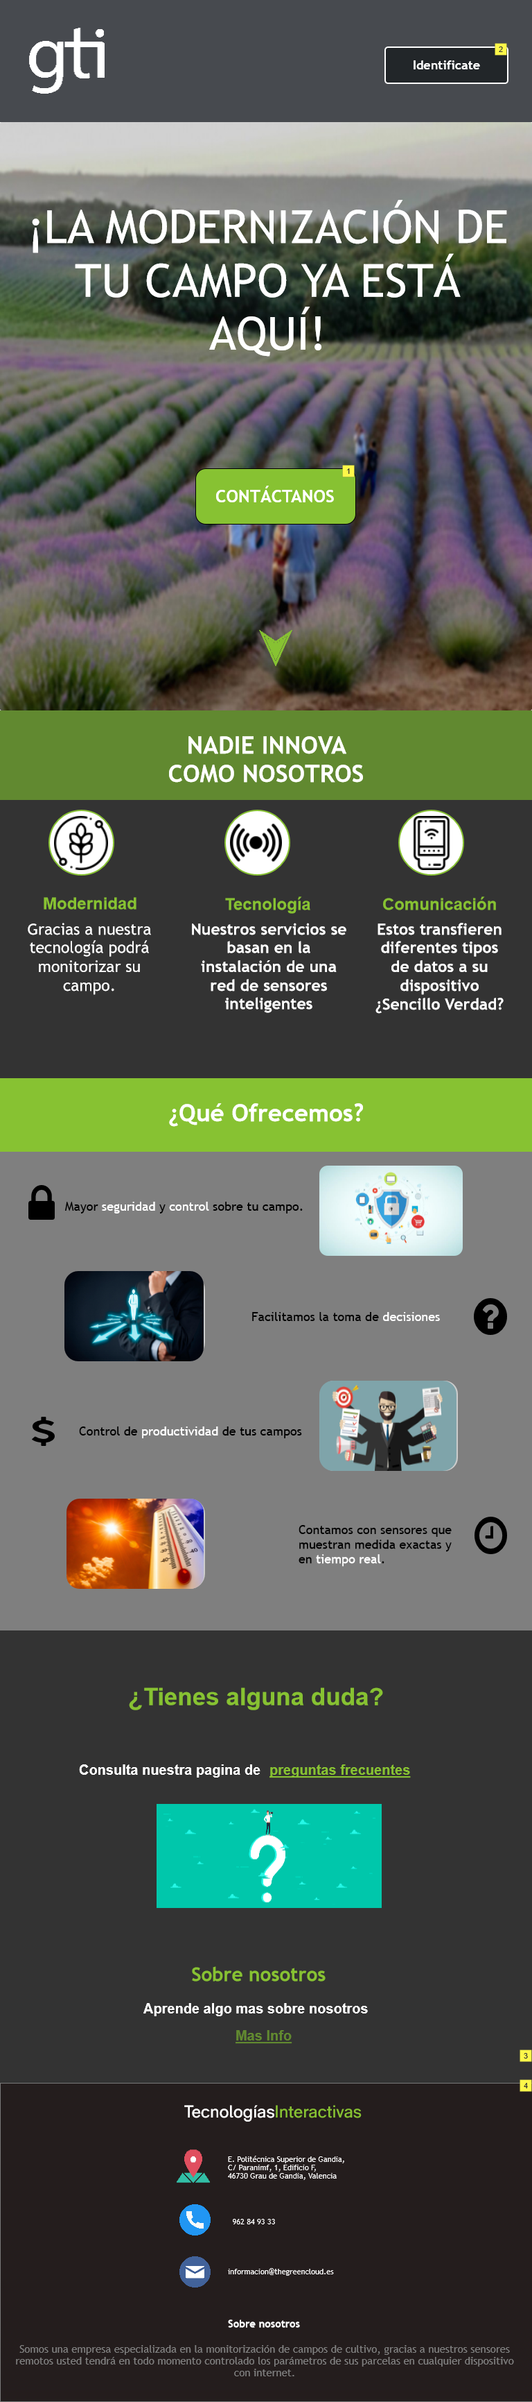

Large Display

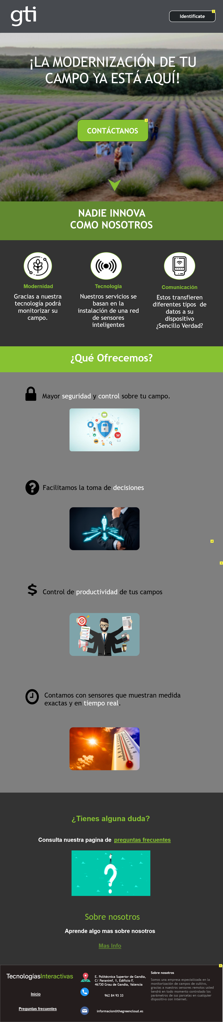

* + 1. Widget Table

| Note number | Name | Interactions | Note |
| --- | --- | --- | --- |
| 1 | Contactanos |  | Para darle más información al cliente. |
| 2 |  |  | Aquí se autentifica el cliente para acceder a sus datos. |
| 3 |  |  | icio |
| 4 |  |  | icio |
| 5 |  |  | icio |

* 1. Form
     1. User Interface

iPhone 8



iPad 4

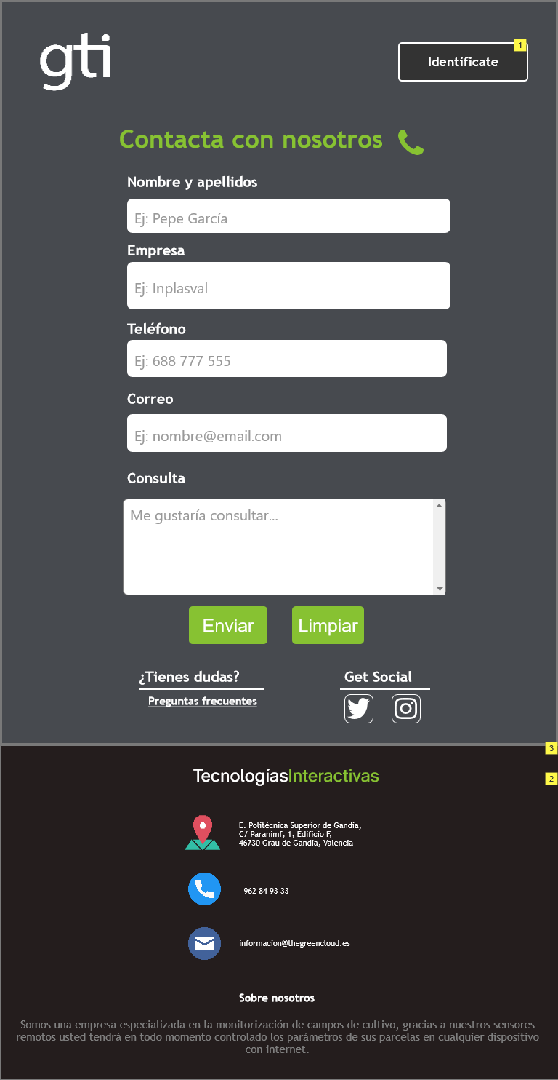

Large Display

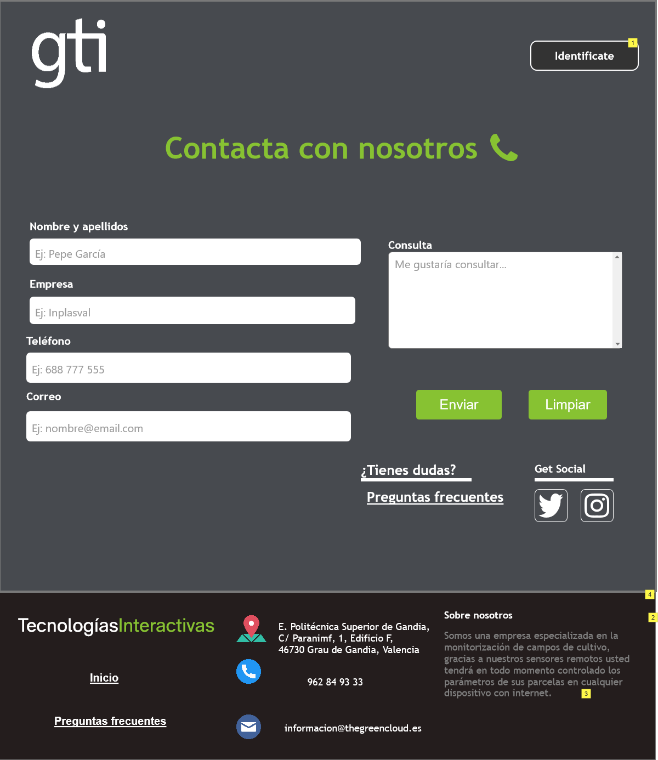

* + 1. Widget Table

| Note number | Name | Interactions | Note |
| --- | --- | --- | --- |
| 1 |  |  | Aquí se autentifica el cliente para acceder a sus datos. |
| 2 |  |  | icio |
| 3 |  |  | icio |
| 4 |  |  | icio |

* 1. Faq's
     1. User Interface

iPhone 8

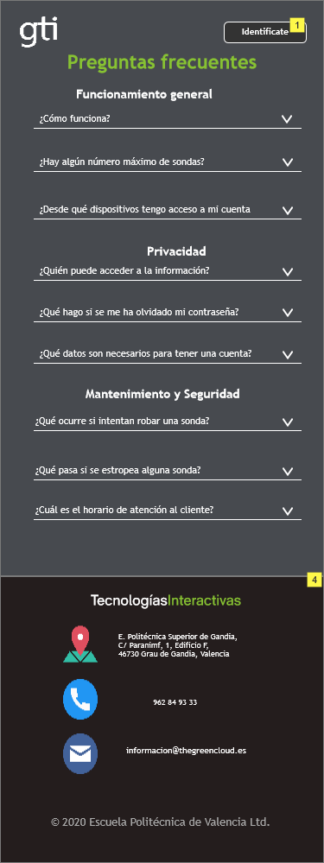

iPad 4

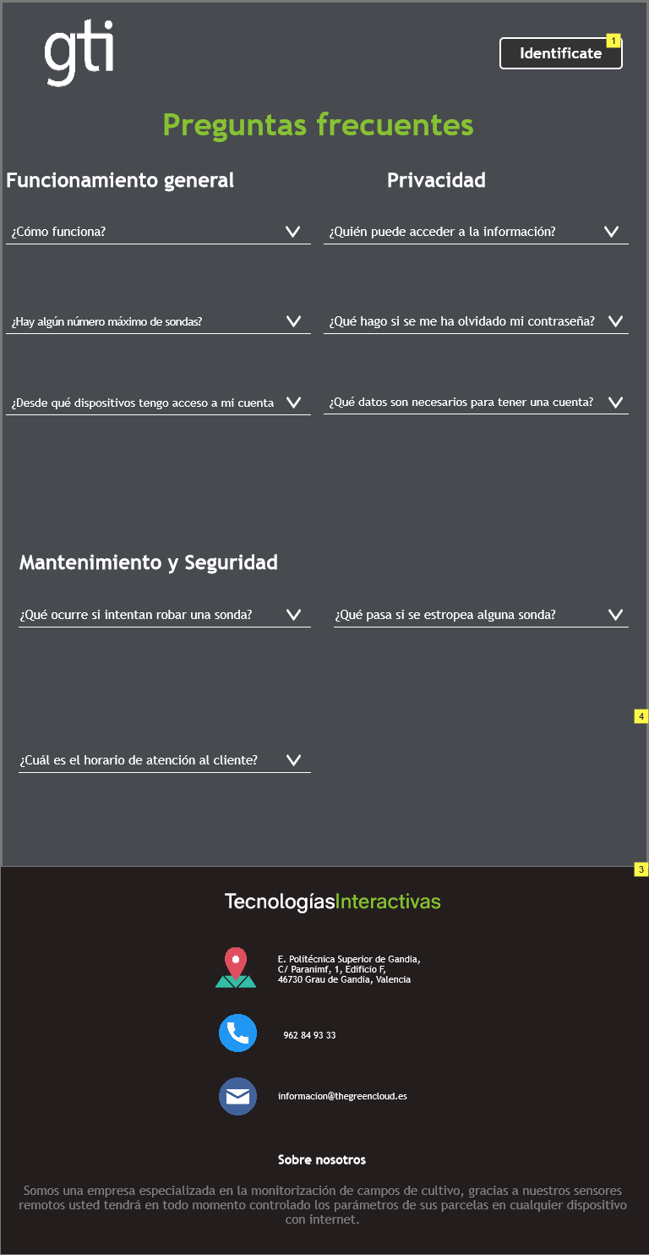

Large Display

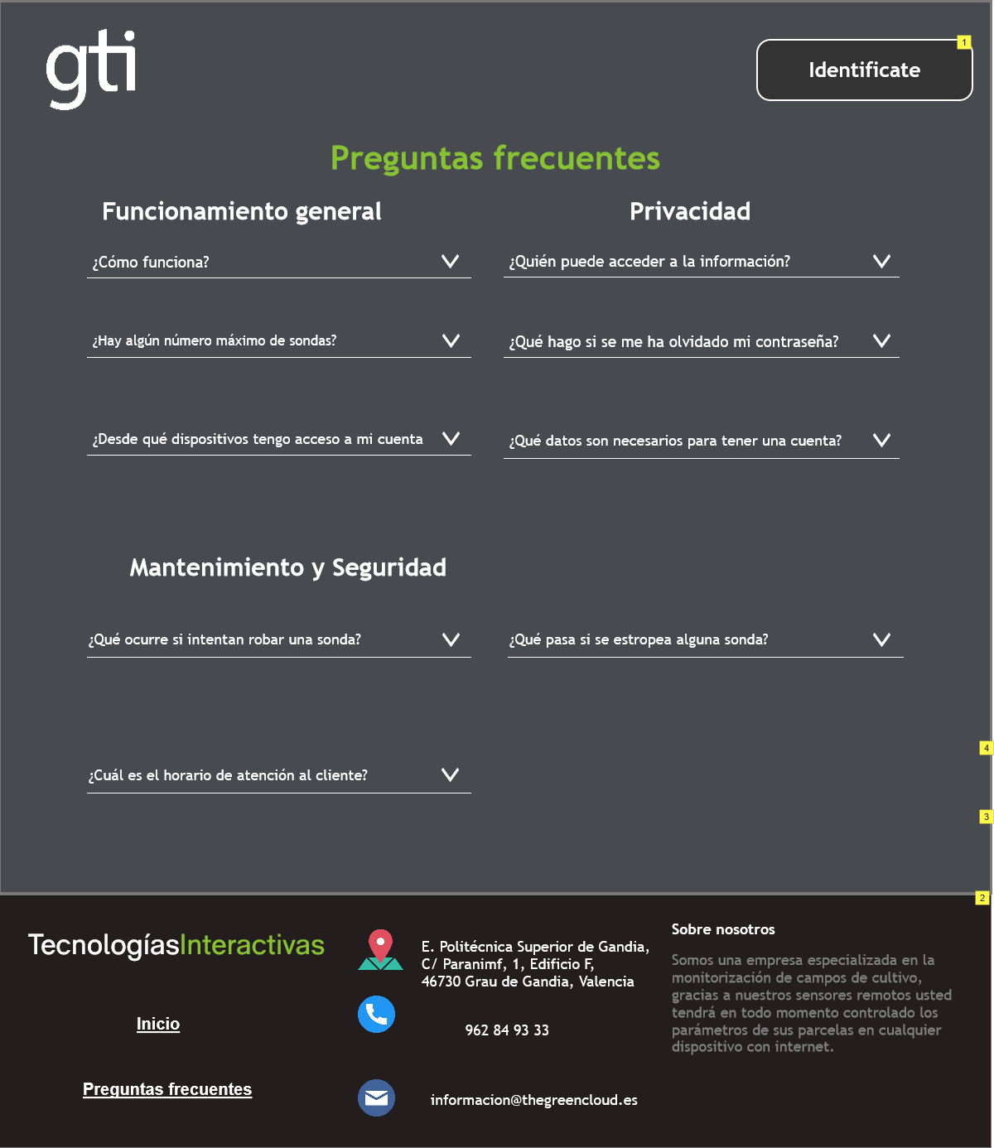

* + 1. Widget Table

| Note number | Name | Interactions | Note |
| --- | --- | --- | --- |
| 1 |  |  | Aquí se autentifica el cliente para acceder a sus datos. |
| 2 |  |  | icio |
| 3 |  |  | icio |
| 4 |  |  | icio |

* 1. Noticias relacionadas
     1. User Interface

iPhone 8

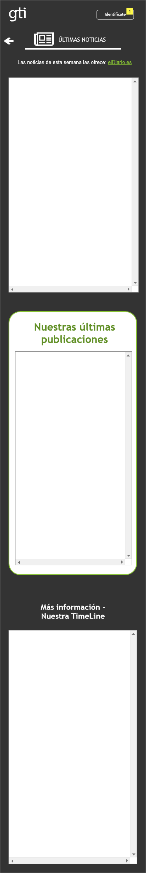

iPad 4

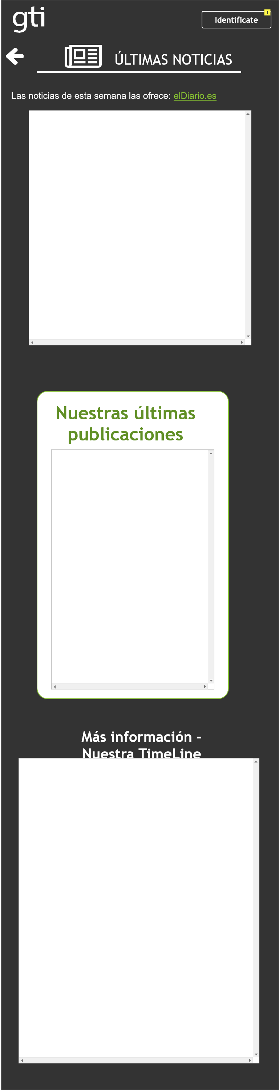

Large Display

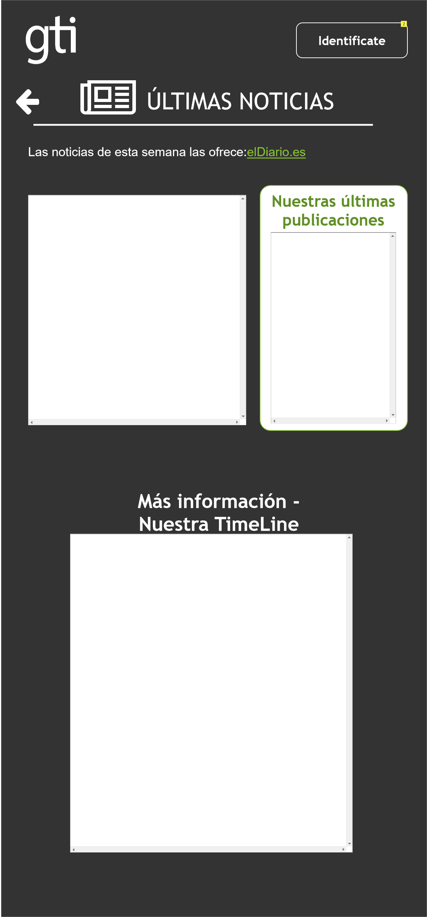

* + 1. Widget Table

| Note number | Name | Interactions | Note |
| --- | --- | --- | --- |
| 1 |  |  | Aquí se autentifica el cliente para acceder a sus datos. |
| 2 |  |  | Aquí se autentifica el cliente para acceder a sus datos. |

* 1. Login
     1. User Interface

iPhone 8

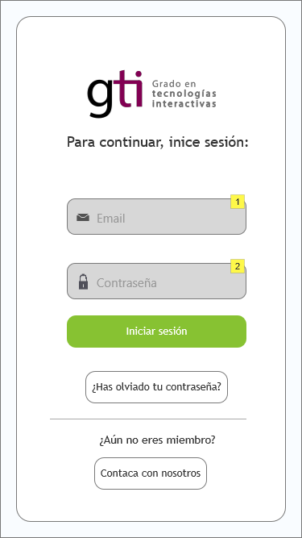

iPad 4

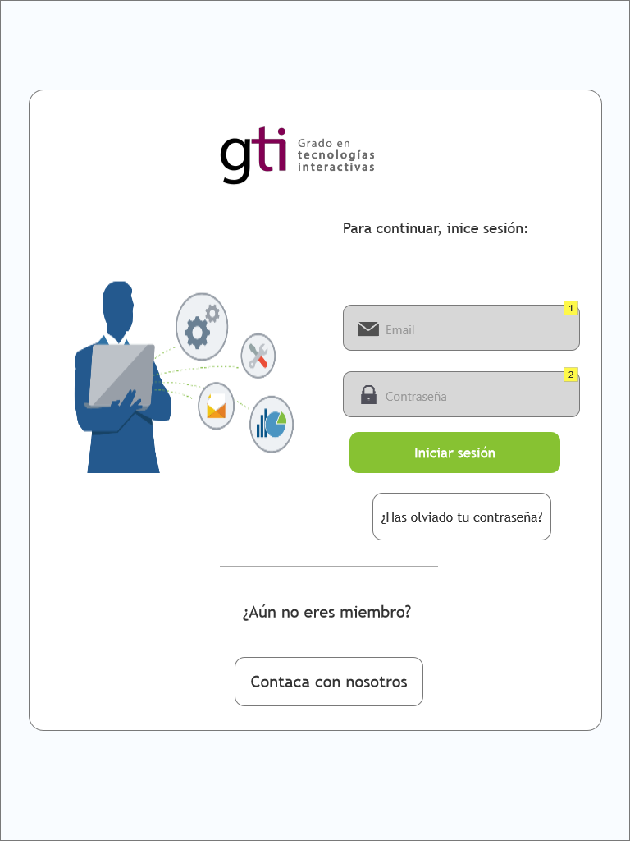

Large Display



* + 1. Widget Table

| Note number | Name | Interactions | Note |
| --- | --- | --- | --- |
| 1 | text_email |  | Correo para iniciar sesion: admin@bancal.es |
| 2 | text_password |  | Contrasela para iniciar sesión: 1234 |

* 1. Graficas Admin
     1. User Interface

iPhone 8

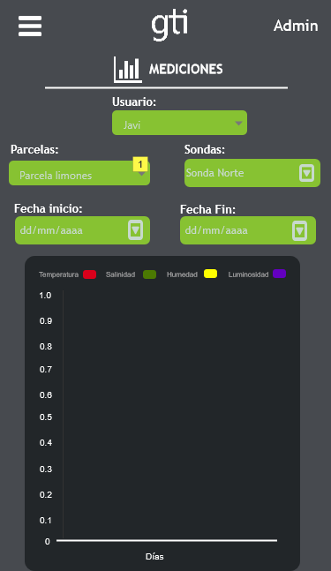

iPad 4

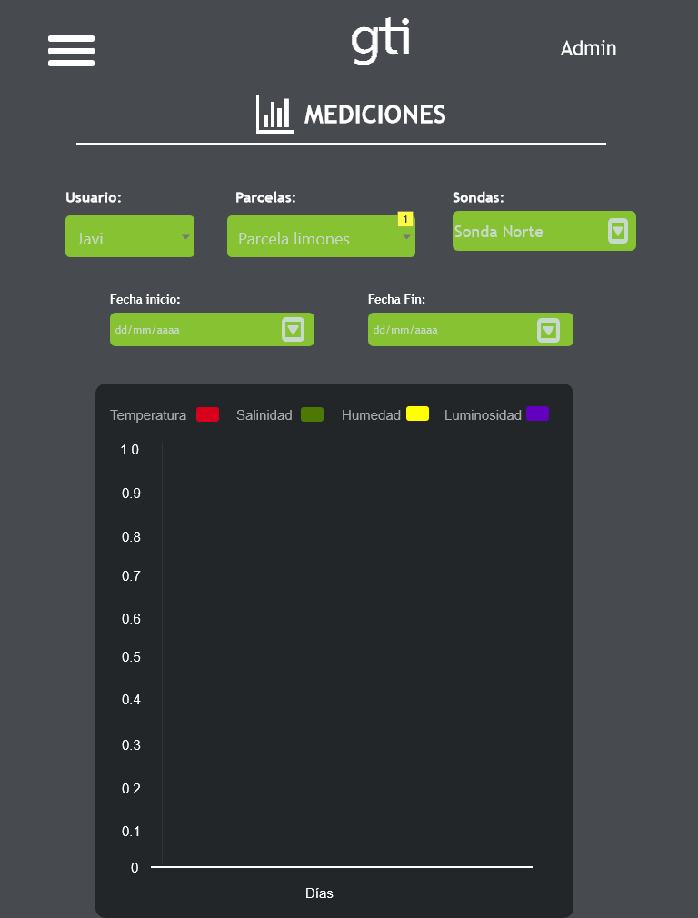

Large Display

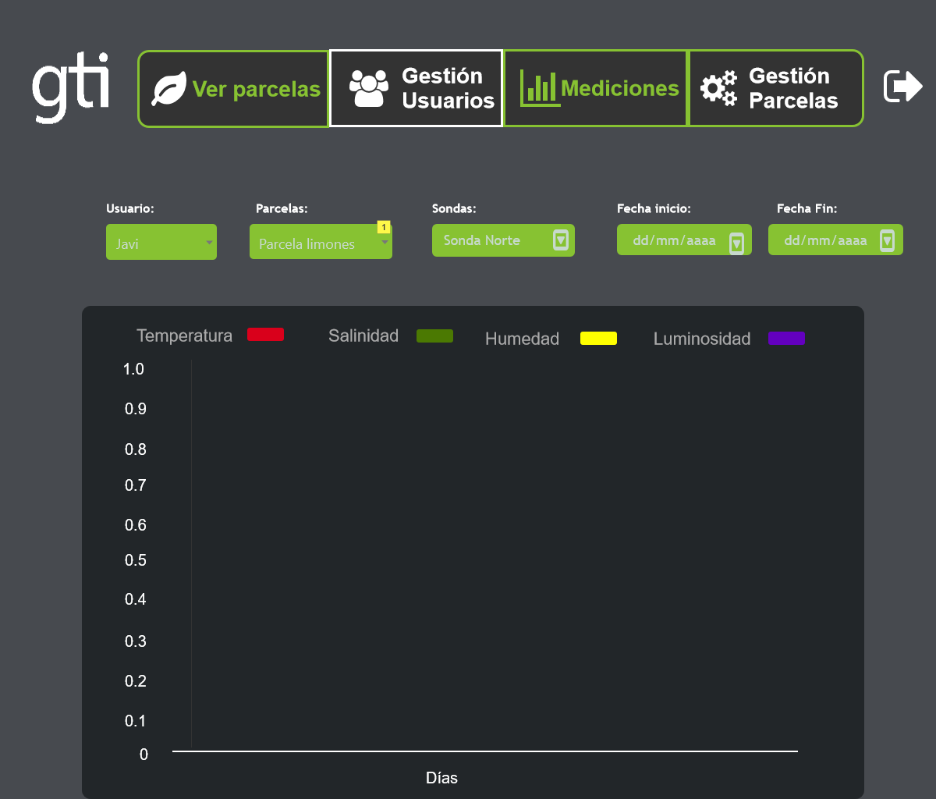

* + 1. Widget Table

| Note number | Name | Interactions | Note |
| --- | --- | --- | --- |
| 1 | selector_parcelas |  | Selecciona la parcela que el usuario quiere que se muestre. |

* + 1. Calendario_fin
       1. State1
       2. User Interface

iPhone 8, iPad 4, Large Display

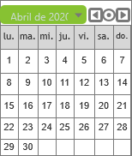

* + 1. Calendario_inicio
       1. State1
       2. User Interface

iPhone 8, iPad 4, Large Display

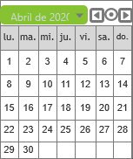

* 1. Admin Page
     1. User Interface

iPhone 8



iPad 4

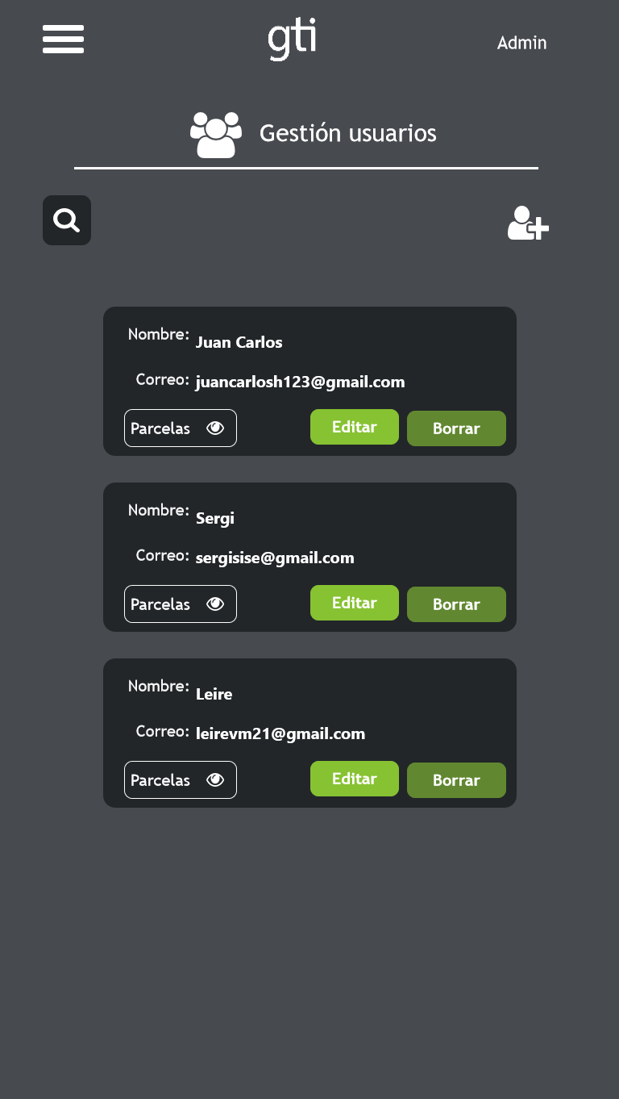

Large Display

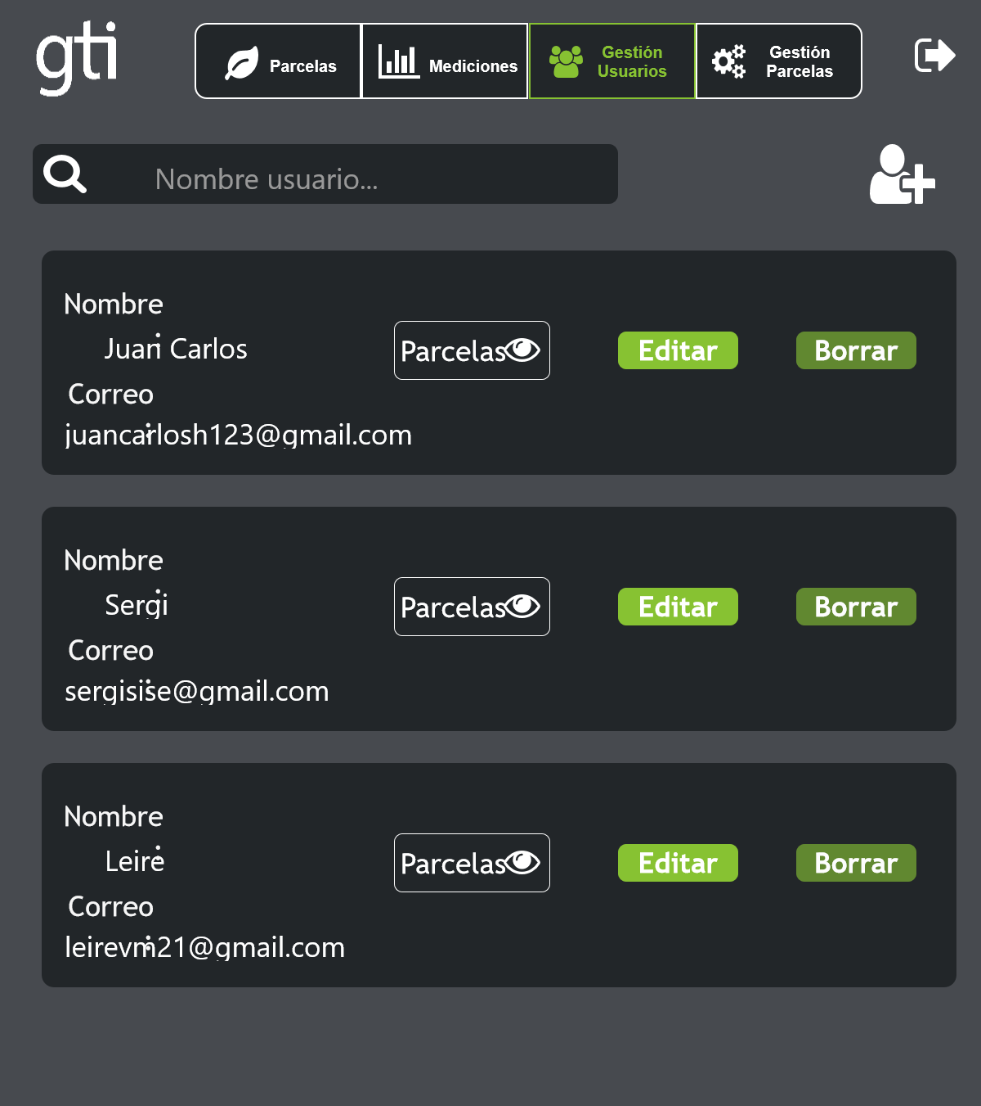

* + 1. Modal Confirmar (No Borrar)
       1. State1
       2. User Interface

iPhone 8

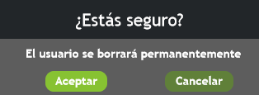

iPad 4

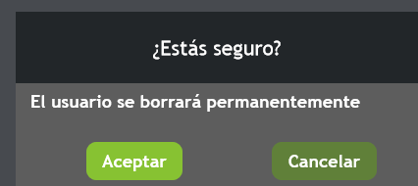

Large Display

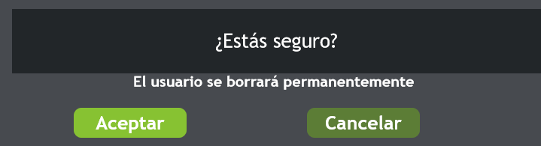

* + 1. modalContraseñasIncorrectas
       1. State1
       2. User Interface

iPhone 8, iPad 4

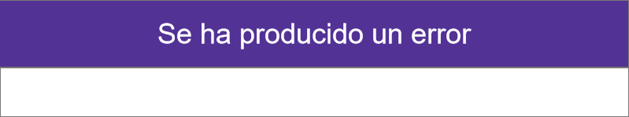

Large Display

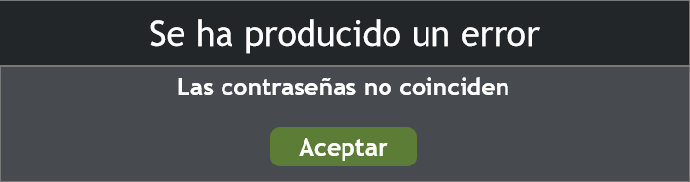

* + 1. panelNuevoUsuario
       1. State1
       2. User Interface

iPhone 8, iPad 4

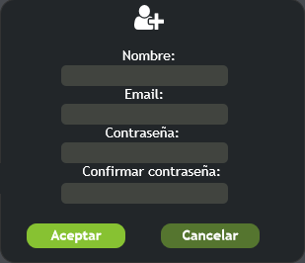

Large Display

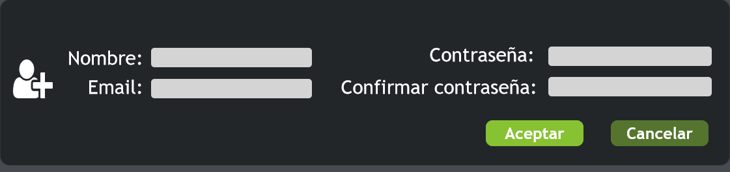

* + 1. modalGestionParcelas (No borrar)
       1. State1
       2. User Interface

iPhone 8



iPad 4



Large Display

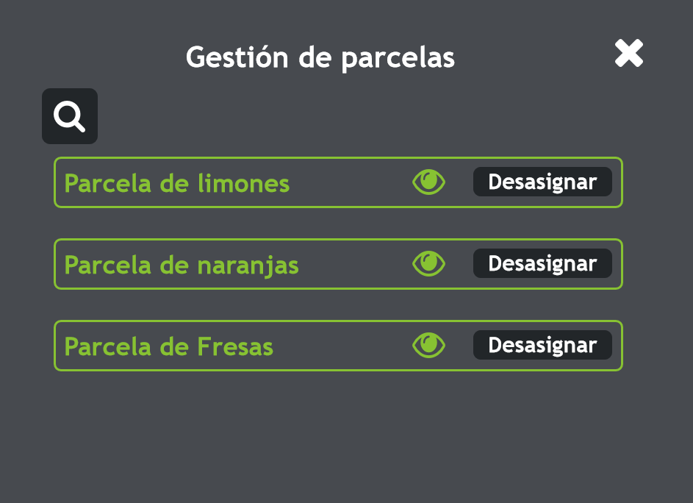

* + 1. visualizar_parcelas
       1. State1
       2. User Interface

iPhone 8, iPad 4, Large Display



* + 1. panelUsers
       1. User 1
       2. User Interface

iPhone 8

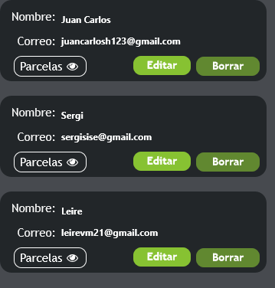

iPad 4

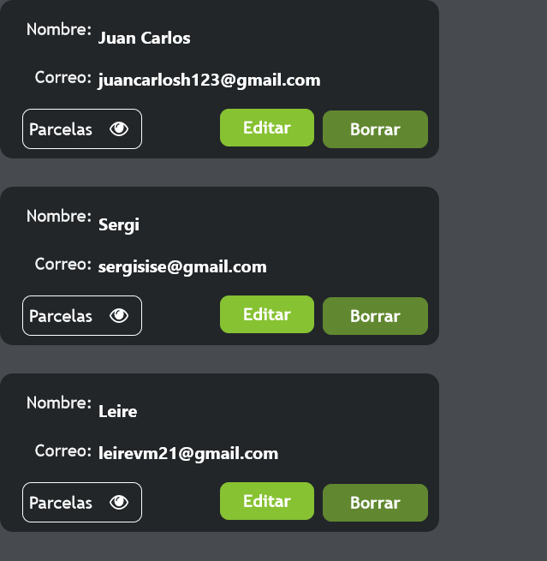

Large Display

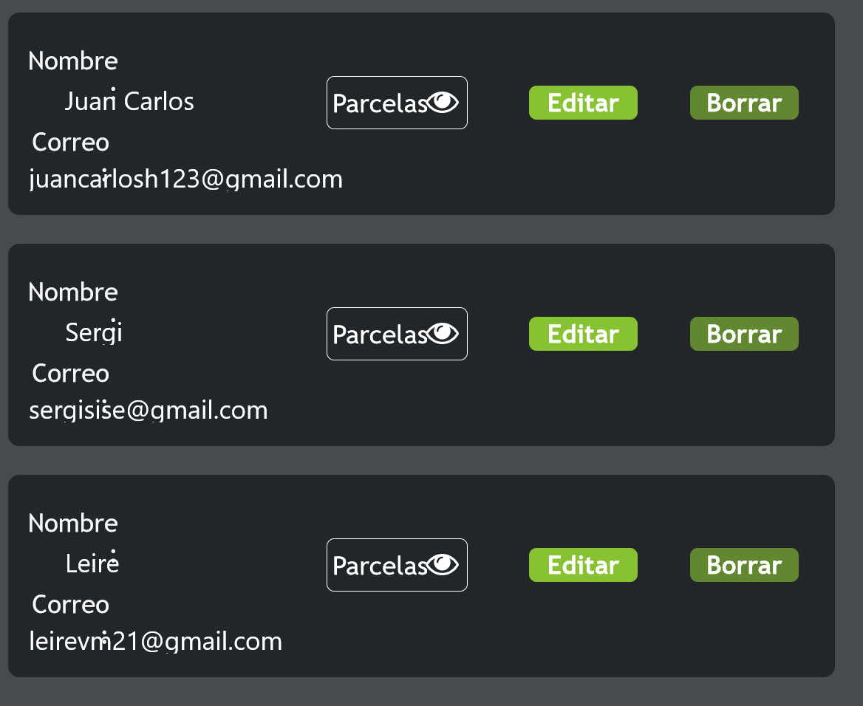

* + - 1. User 2
      2. User Interface

iPhone 8

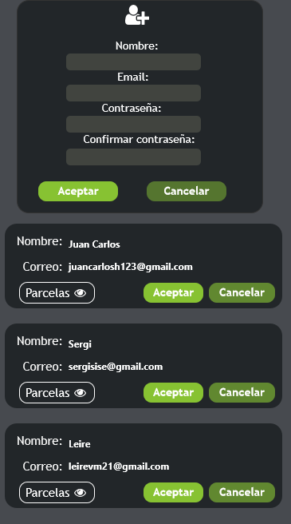

iPad 4

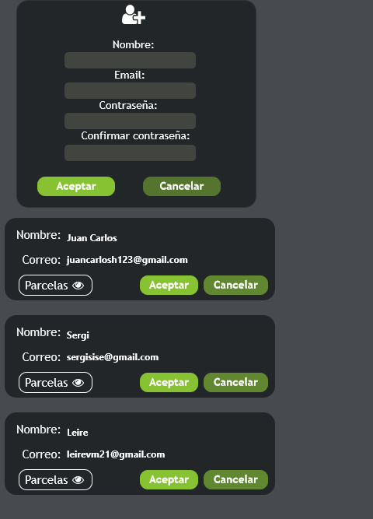

Large Display

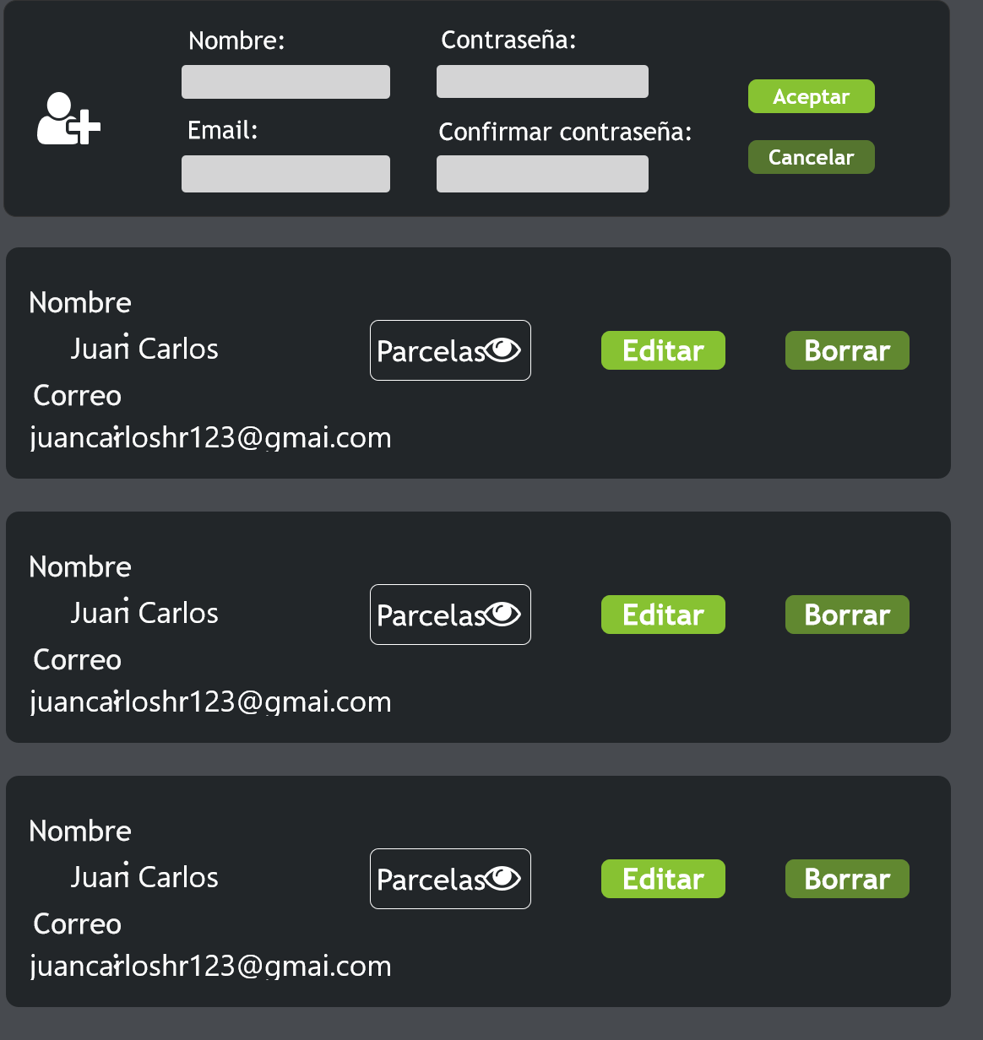

* + 1. ListaParcelas
       1. User Interface

iPhone 8, iPad 4



Large Display



* + 1. repeaterUsers
       1. User Interface

iPhone 8

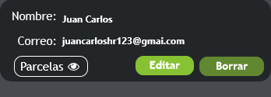

iPad 4

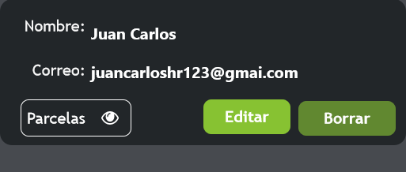

Large Display

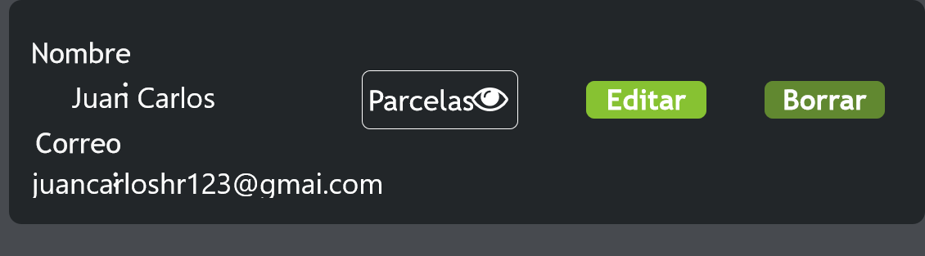

* + 1. repeaterUsers
       1. User Interface

iPhone 8

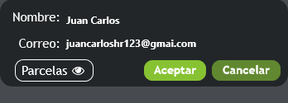

iPad 4



Large Display

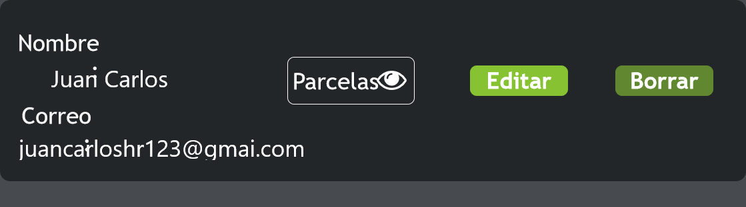

* 1. Gestion campos

Page Mouse Move:

* + 1. User Interface

iPhone 8

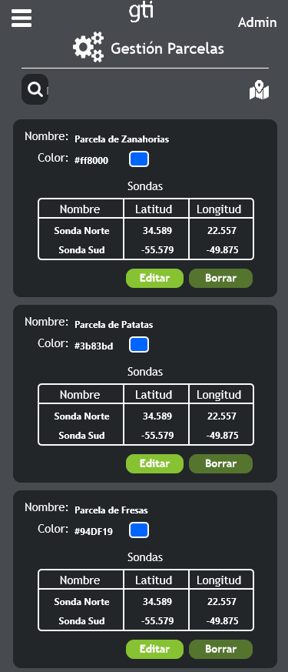

iPad 4

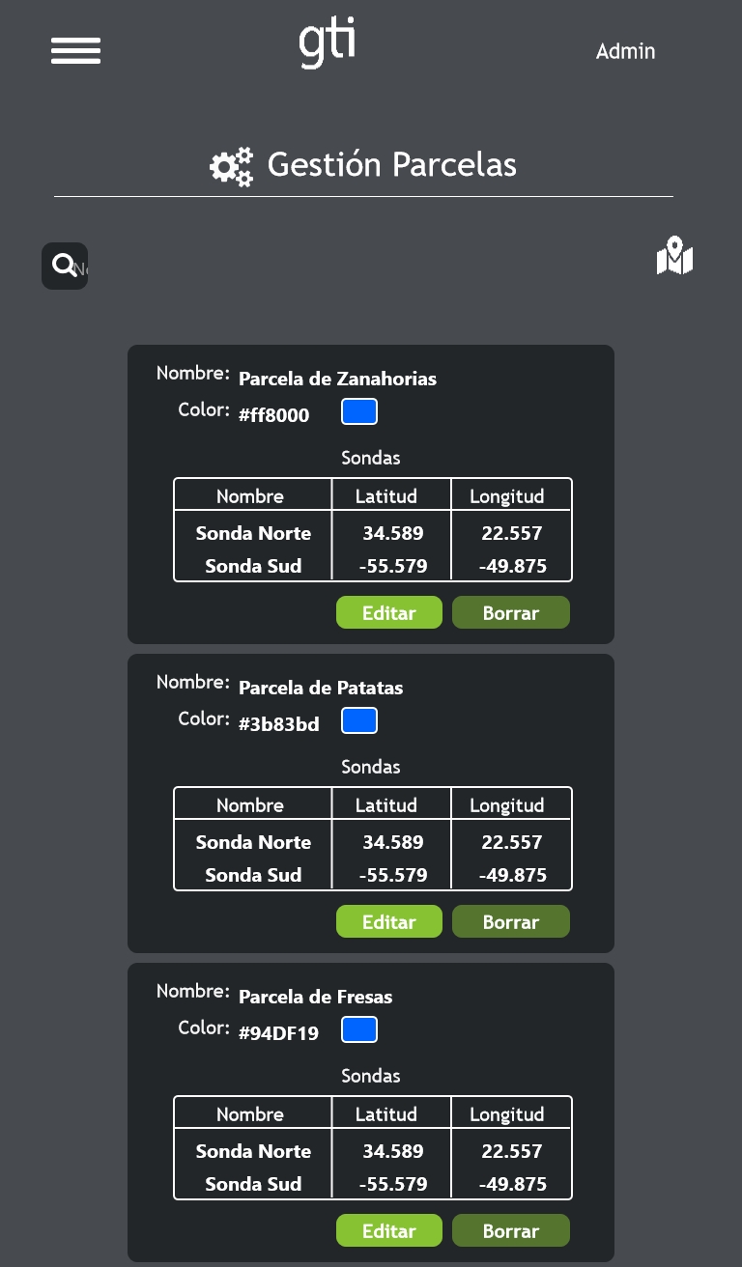

Large Display

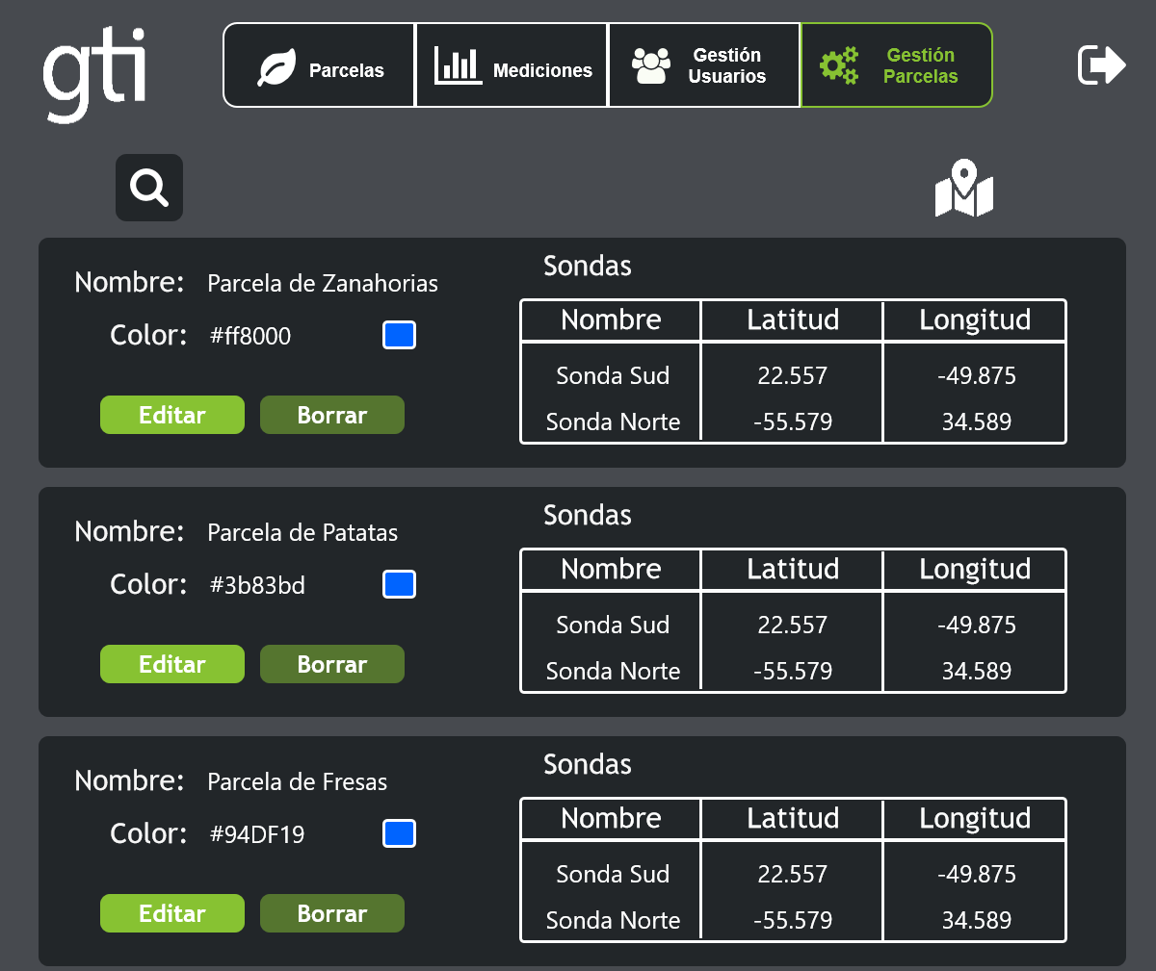

* + 1. Modal Confirmar (No Borrar)
       1. State1
       2. User Interface

iPhone 8

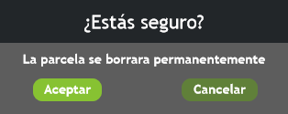

iPad 4

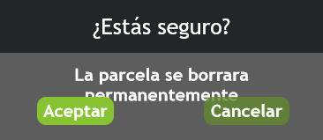

Large Display



* + 1. panelNuevaParcela
       1. State1
       2. User Interface

iPhone 8

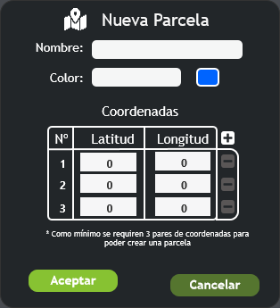

iPad 4

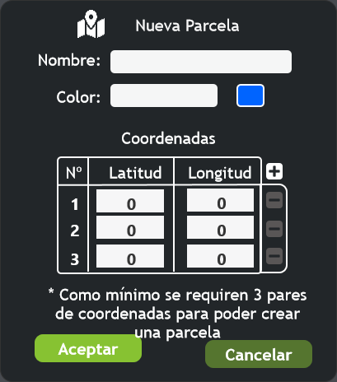

Large Display

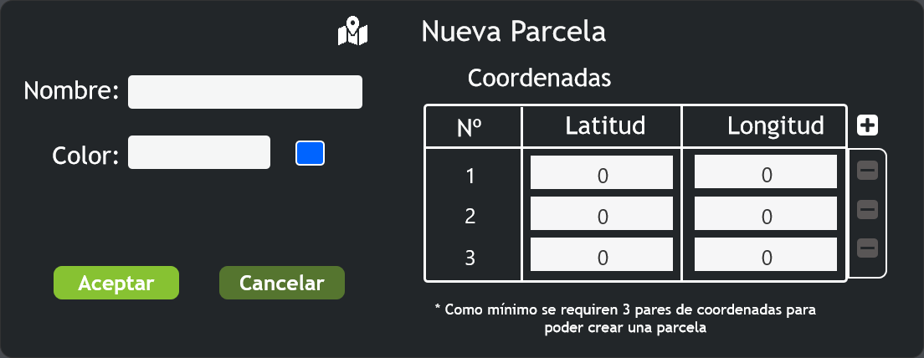

* + 1. modalGestionCoordenadas (No borrar)
       1. State1
       2. User Interface

iPhone 8

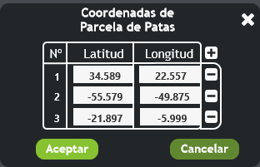

iPad 4

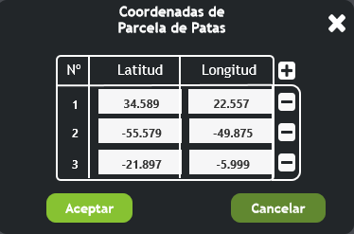

Large Display

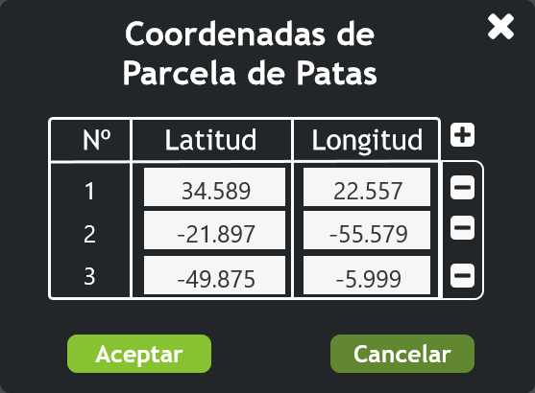

* + 1. ListaParcelas
       1. User Interface

iPhone 8

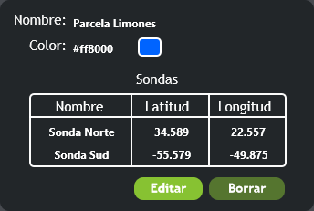

iPad 4

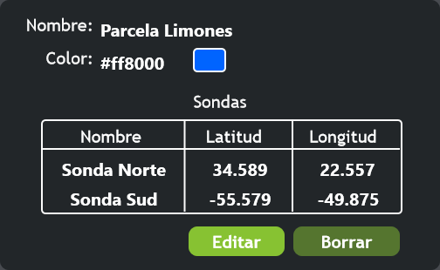

Large Display

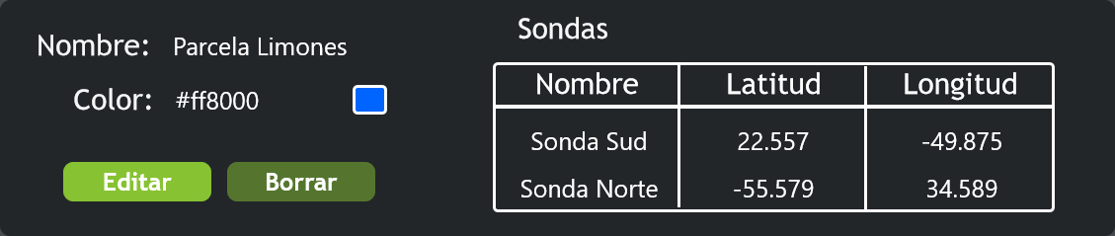

* 1. Parcelas Admin
     1. User Interface

iPhone 8

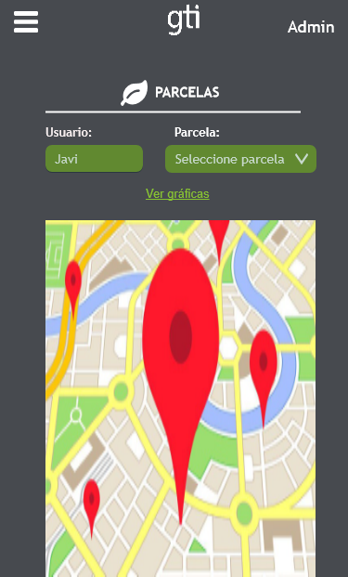

iPad 4

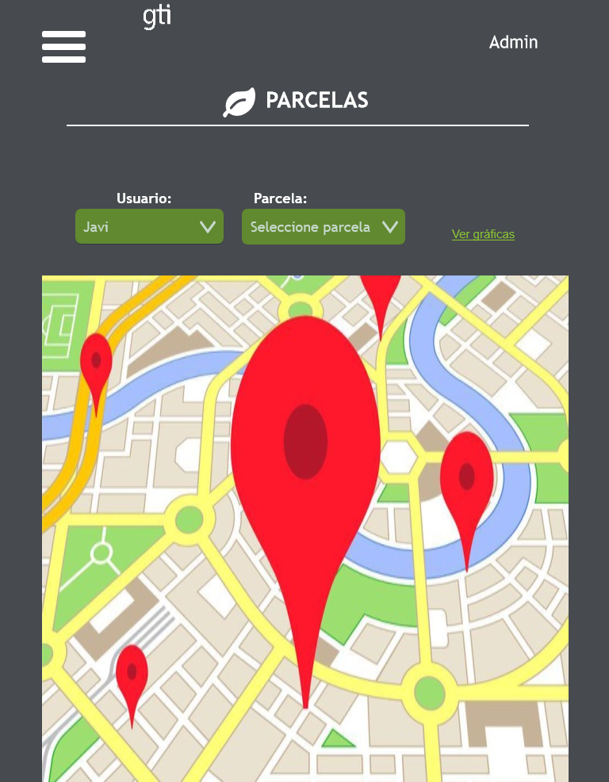

Large Display

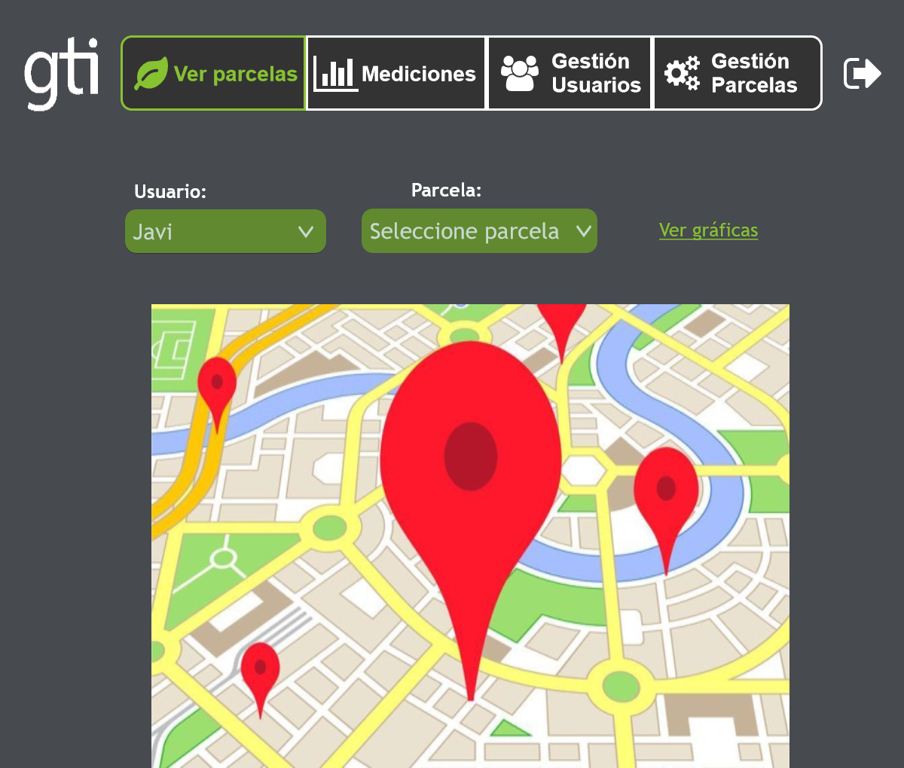

* + 1. dropUsers
       1. State1
       2. User Interface

iPhone 8

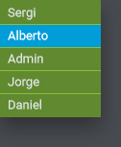

iPad 4

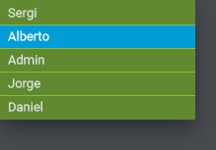

Large Display

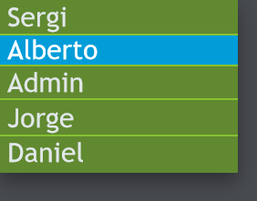

* + 1. dropPacelas
       1. State1
       2. User Interface

iPhone 8

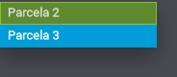

iPad 4

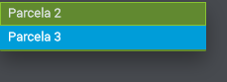

Large Display



* 1. Tiempo User
     1. User Interface

iPhone 8

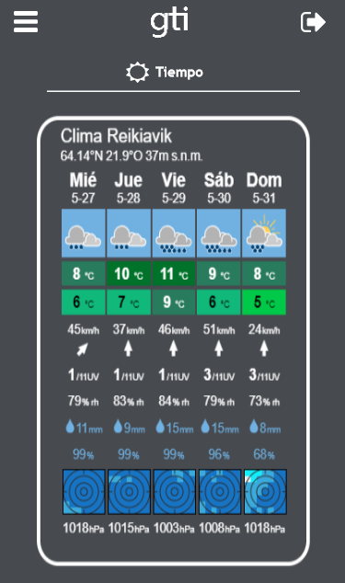

iPad 4

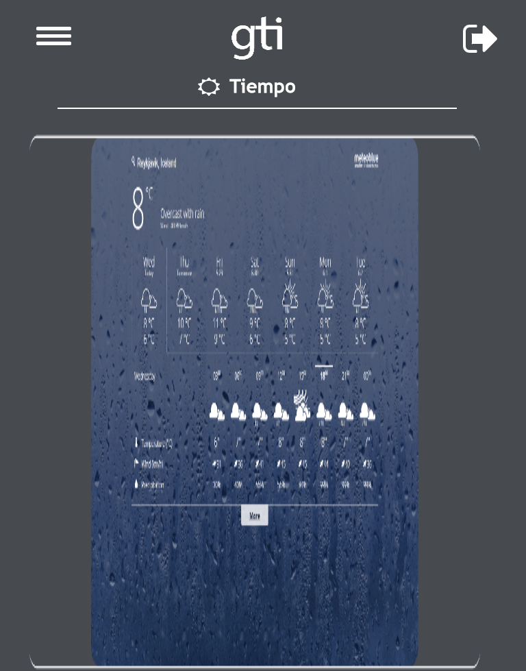

Large Display

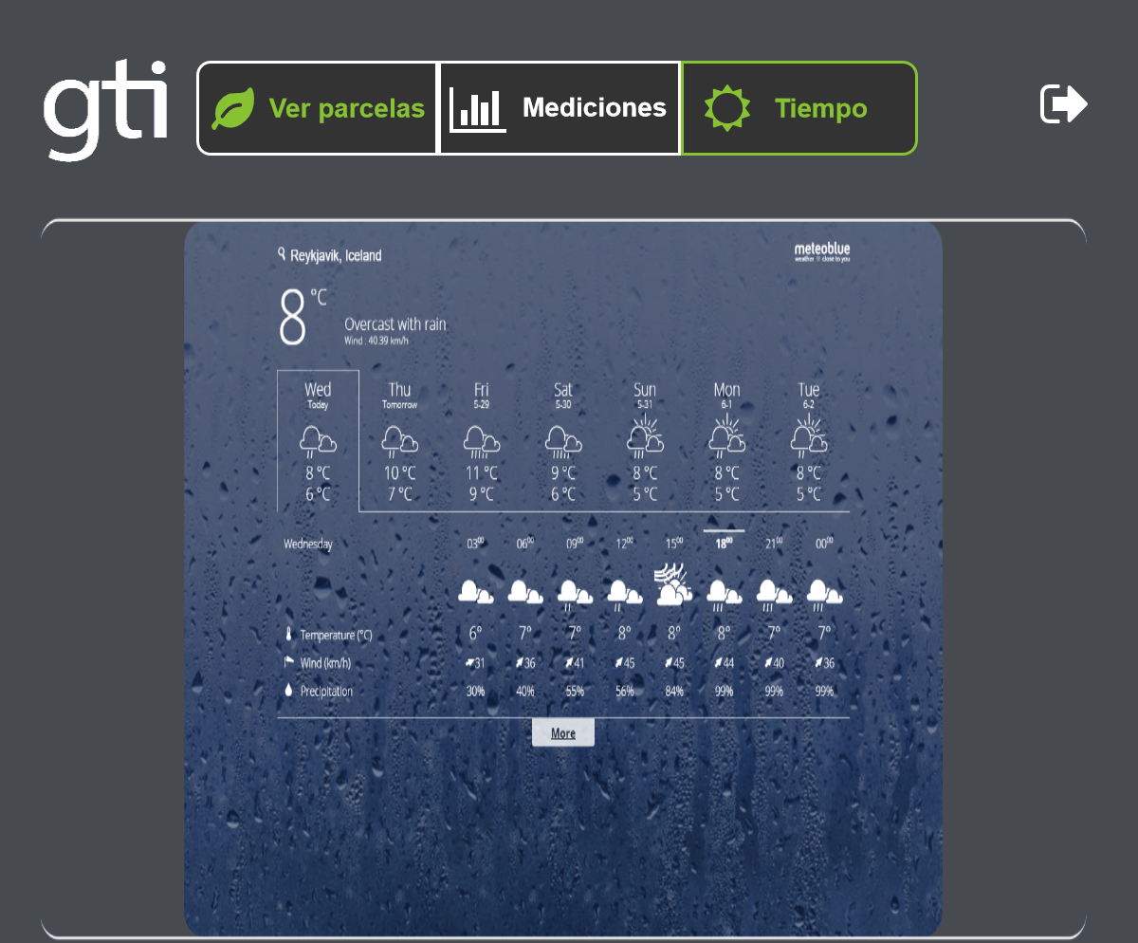

* + 1. MenuMobil
       1. State1
       2. User Interface

iPhone 8

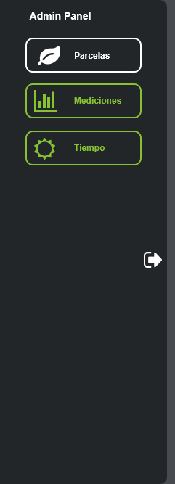

iPad 4, Large Display

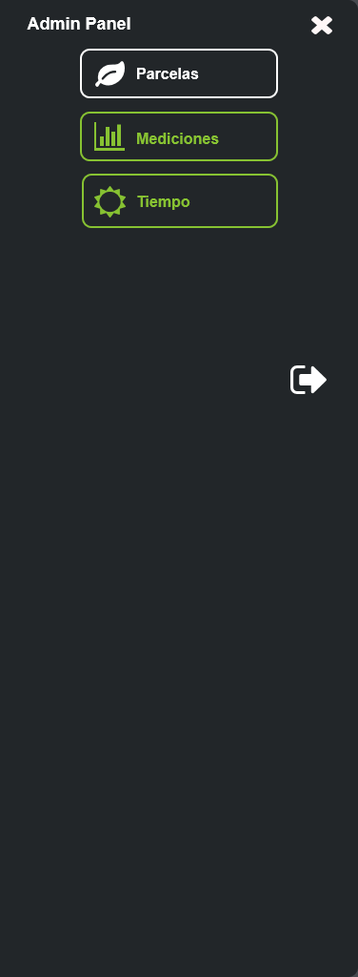

* 1. Graficas User
     1. User Interface

iPhone 8

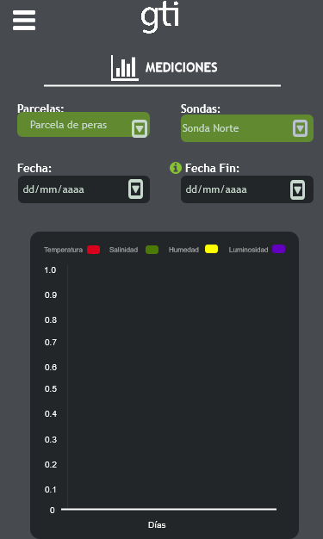

iPad 4

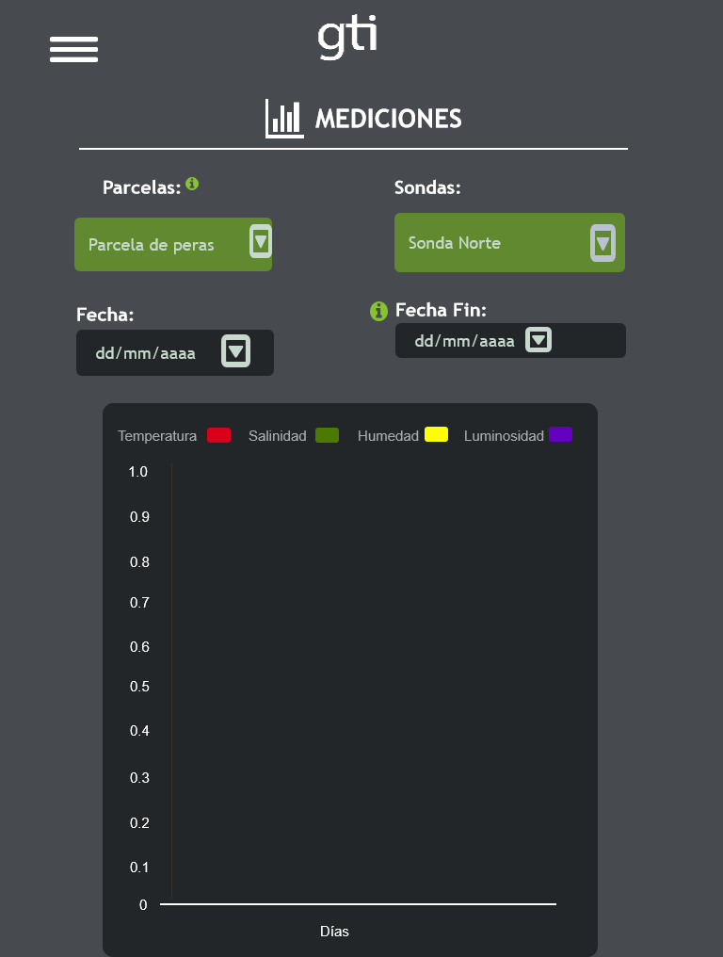

Large Display

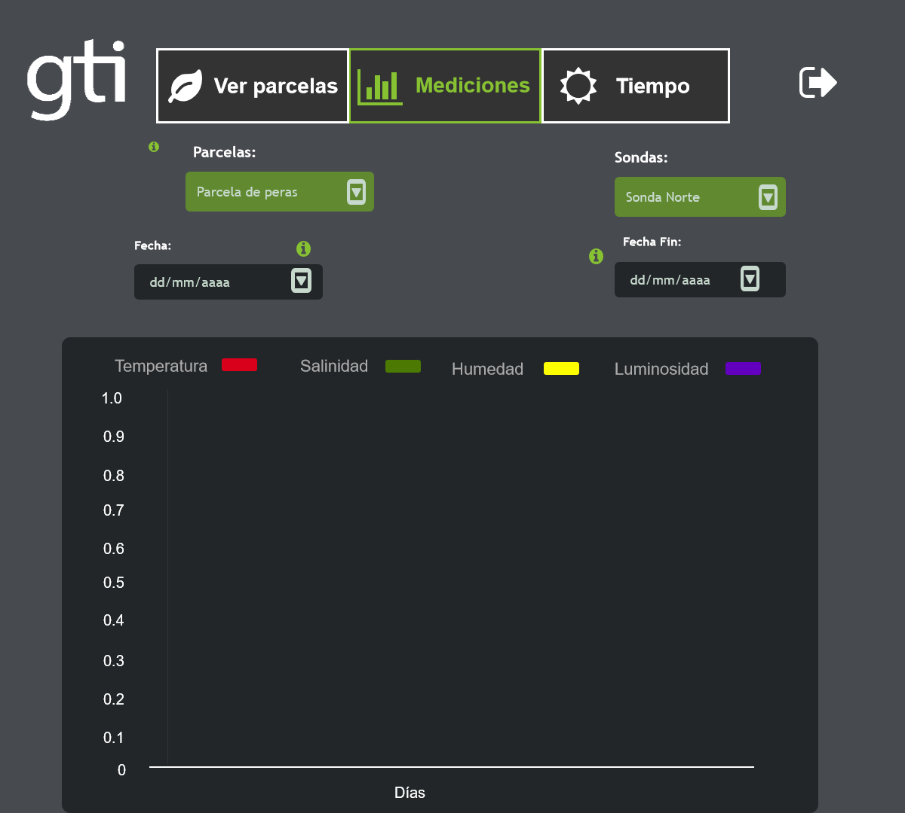

* + 1. MenuMobil
       1. State1
       2. User Interface

iPhone 8

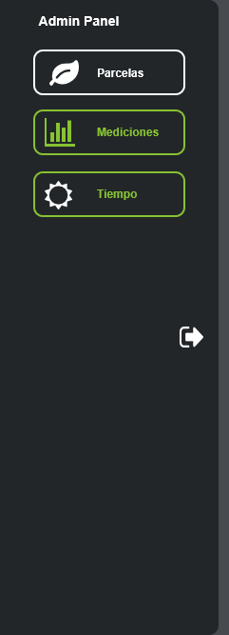

iPad 4, Large Display

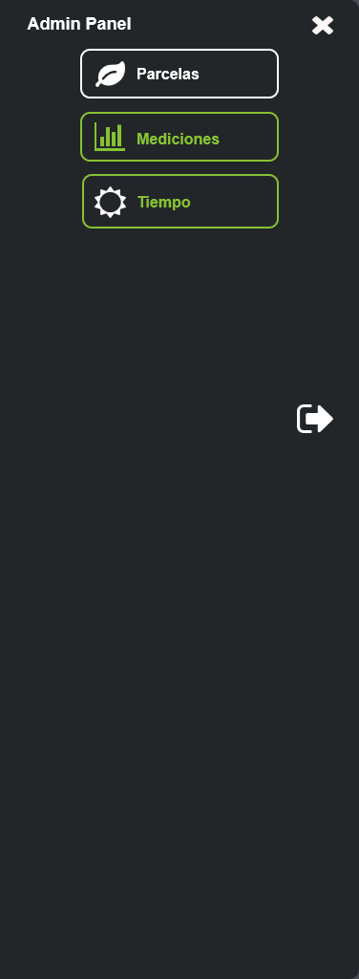

* + 1. Calendario_inicio
       1. State1
       2. User Interface

iPhone 8, iPad 4, Large Display



* + 1. Calendario_fin
       1. State1
       2. User Interface

iPhone 8, iPad 4, Large Display



* 1. Parcelas User
     1. User Interface

iPhone 8

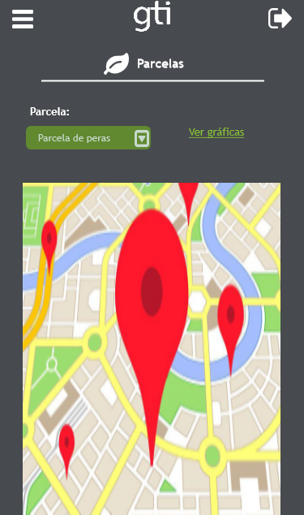

iPad 4

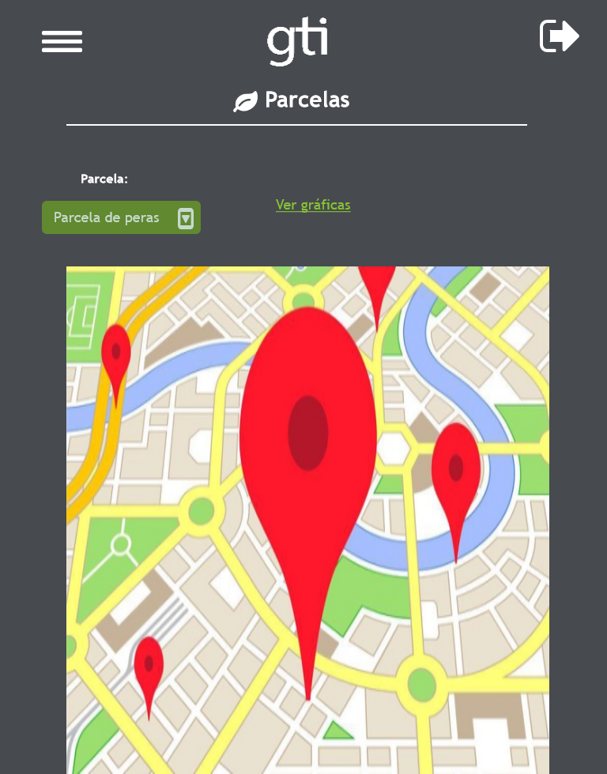

Large Display

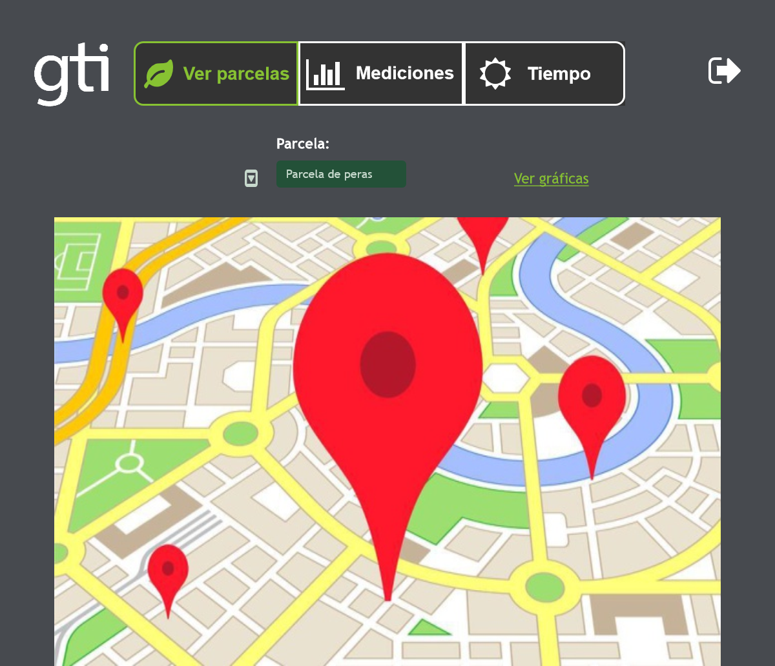

* + 1. MenuMobil
       1. State1
       2. User Interface

iPhone 8

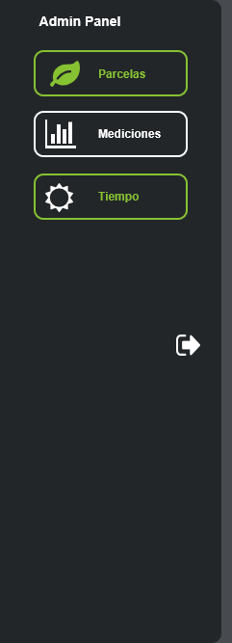

iPad 4, Large Display

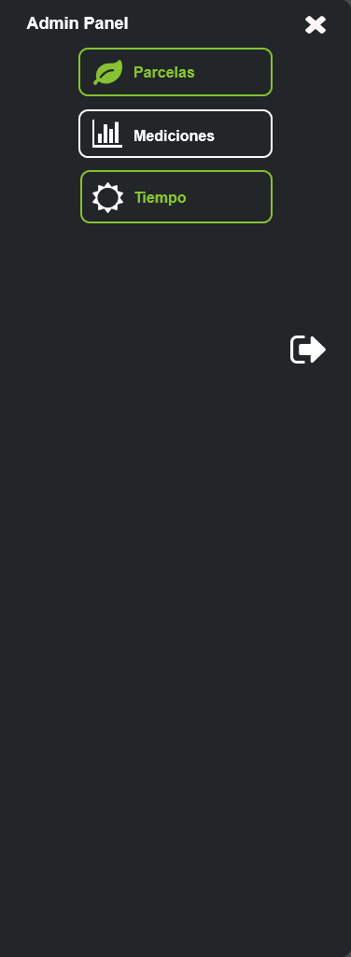

* 1. Recuperar Password
     1. User Interface

iPhone 8

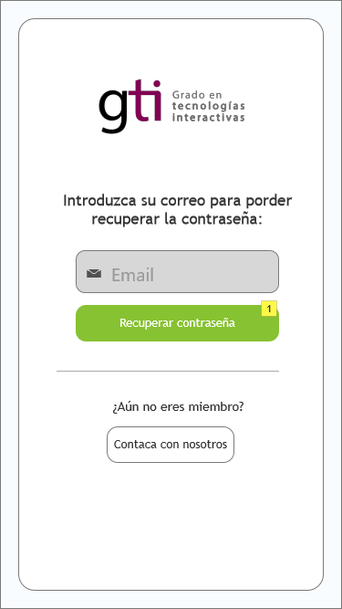

iPad 4

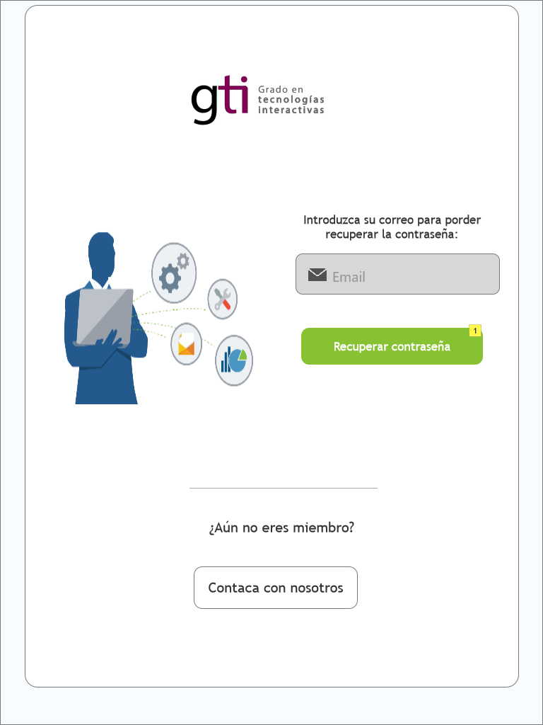

Large Display



* + 1. Widget Table

| Note number | Name | Interactions | Note |
| --- | --- | --- | --- |
| 1 | btn_iniciar_sesion |  | Correo correcto: thegreencloud.upv@gmail.com |

* + 1. correoCorrecto
       1. State1
       2. User Interface

iPhone 8

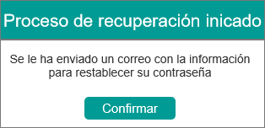

iPad 4

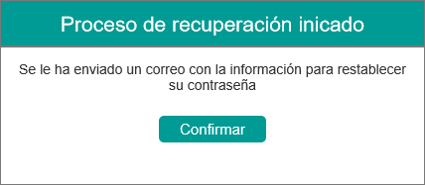

Large Display

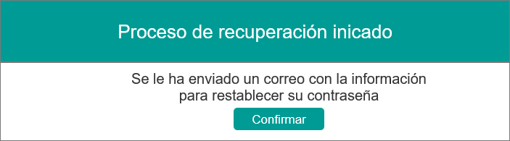

* + 1. correoIncorrecto
       1. State1
       2. User Interface

iPhone 8

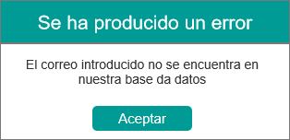

iPad 4

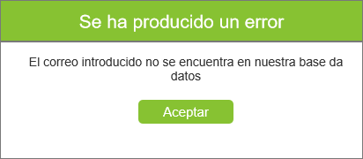

Large Display

